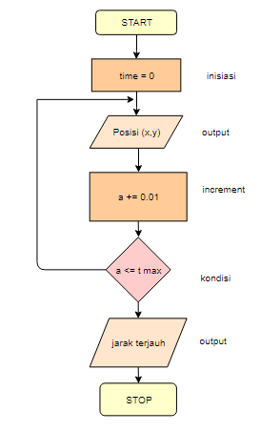

Putri Yulianti Suhayat

18318004